**Final Assignment:**

→ Create an account on Github

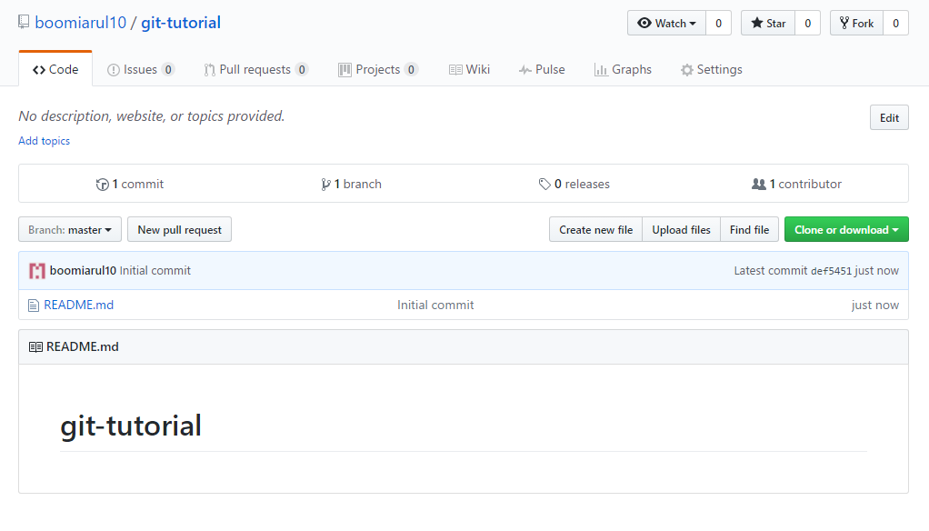

→ Fork the repository that will be created by the trainer for the project

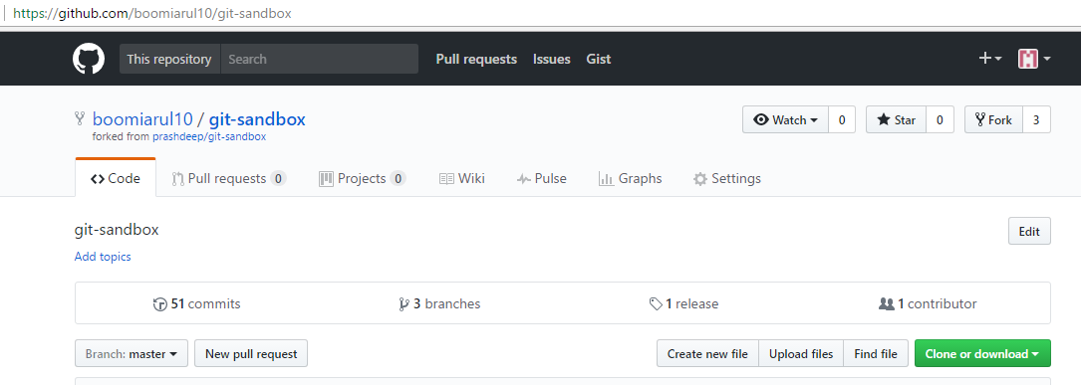

→ Clone the forked repository on to local machine

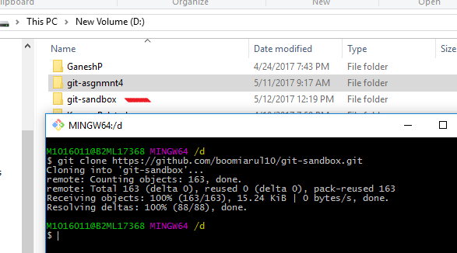

→ Create feature branch on the local machine

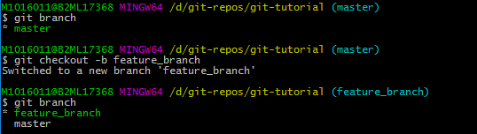

→ Configure the upstream repo

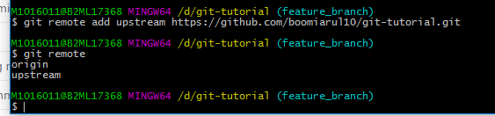

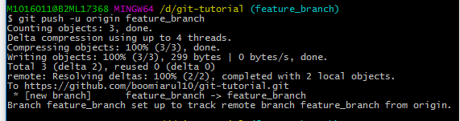

→ Add some files, edit the files. remove some files and finally commit the changes to the feature branch and push it to the origin repo

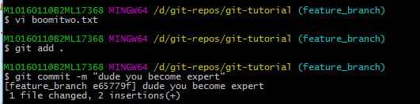

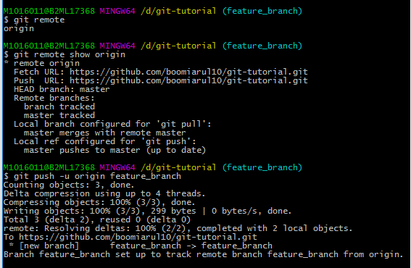

→ Create a pull request for other developers

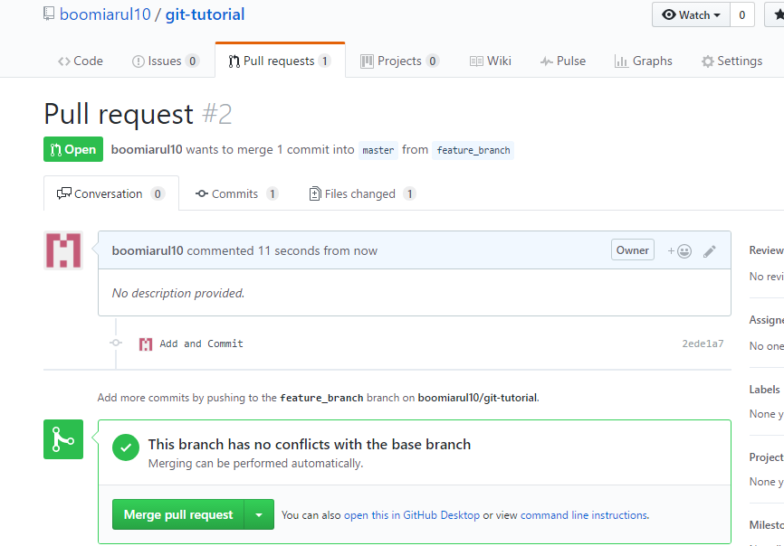

→ Work on the pull request feature and provide comments on Github UI

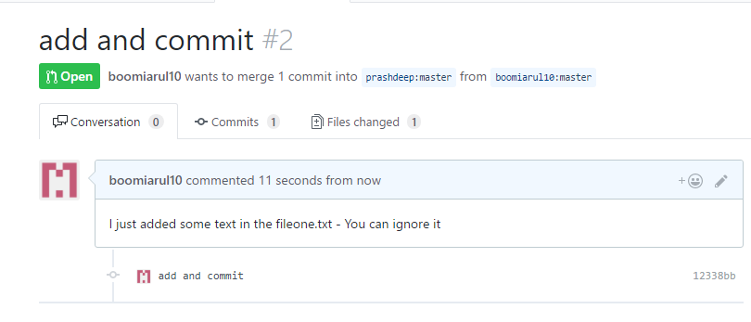

→ Merge the changes from the pull repository of other collaborators to their local repo

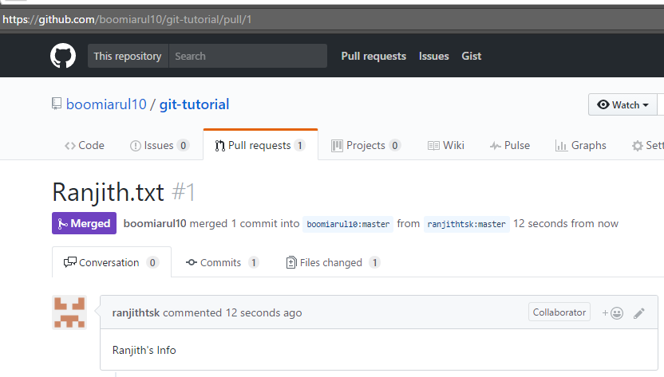

→ Push the changes to the main branch and finally delete the feature branches

